NATIONAL UNIVERSITY OF SCIENCES AND TECHNLOGY

(DEPARTMENT OF MECHANICAL ENGINEERING)

FUNDAMENTALS OF PROGRAMMING

NAME: Manahil Shahzad

SUBMITTED ON: 10-19-2023

ID: 466695

TASK 1

#include <iostream>

using namespace std;

int main(){

int m=0;

int sum=0;

cout<<"enter number you wish to sum"<<endl; cin>>m;

for( int i=1; i<=m;i++){

sum +=i;

}

cout<<"the sum of "<<m<<" first number is: "<<sum<<endl;

return 0;

}

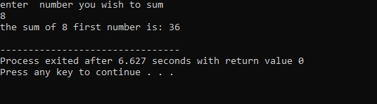

TASK 2

#include <iostream>

using namespace std;

int main(){

int no=0;

cout<<"enter the number";

cin>> no;

cout<<"table of"<<no<<endl;

for(int z=1 ;z<=10 ;z++){

cout<<no<<"x"<<z<<"="<<no \*z<< endl;

}

return 0;

}

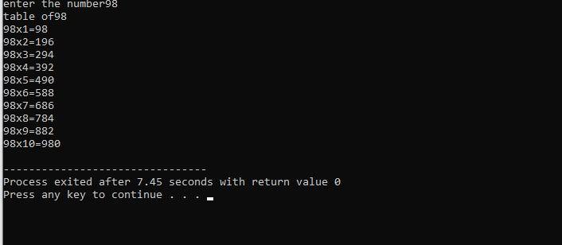

Task 3

#include <iostream>

using namespace std;

int main(){

int factorial=1;

int hill;

cout<<"enter a number to find a factorial"<<endl;

cin>>hill;

for( int a=1; a<=hill;a++)

{

factorial \*=a;

}

cout<<factorial<<endl;

return 0;

}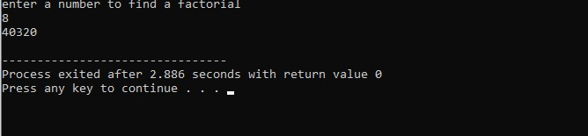

TASK 4

#include <iostream>

using namespace std;

int main(){

int sequence, second=1, first =0;

int m;

cout<<"enter number for sequence values:"<<endl;

cin>>m;

cout<<"the fibonocci sequence for"<<m<<"values is: "<<endl;

for (int i=1; i<=m; i++)

if (i<=0){

sequence=i;

}

else {

sequence =first+second;

first =second;

second=sequence;

cout<<sequence<<endl;

}

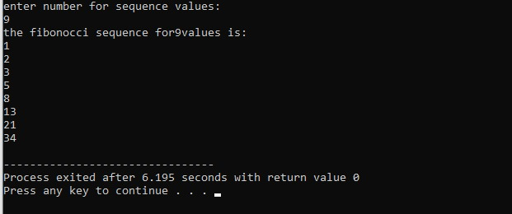 return 0;

}